Conditions and Habits of Successful Partnerships Guidance

Summer 2015

Table of Contents
Overview 1
Standards for Effective Partnerships 3
Readiness for Partnership Tool 4
Alignment 4
Readiness for Partnership Tool – Purpose and Process 5
Readiness for Partnership Tool 6
Contract Supplement Alignment 7
Alignment 7
Contract Supplement – Purpose and Process 8
Contract Supplement 8
Quarterly Meeting Agenda 9
Alignment 9
Quarterly Meeting Agenda – Purpose and Process 10
Sample Agenda for Quarterly Meeting 10
Appendix A: Alignment of Tools 11
Readiness for Partnership 11
Contract Supplement 13
Quarterly Meeting Agenda 15
Appendix B: Tools to Print 17
Readiness for Partnership Tool 17
Contract Supplement 19
Quarterly Meeting Agenda 21

Background
In the spring of 2015, the Office of District and School Turnaround (ODST) reviewed the Priority Partners initiative by gathering the perspective and experience of districts and partners, as well as looking at related research1 in order to provide both districts and partners with guidance on effective partnerships. The impetus for this work is that every one of the exited 2010 Massachusetts Level 4 schools was supported by
one or more partners who injected experience, tools, implementation know-how, and individual expertise. However, the majority of the unsuccessful 2010 Level 4 schools were supported by one or more partners – many of which were the same partners that worked with the successful schools.
The interviews, focus groups, and research led to the conclusion that there are necessary conditions at the outset of a partnership, as well as ongoing habits throughout a partnership, that make the difference between successful and unsuccessful relationships. This led to a theory of action: If districts and partners establish conditions for success and monitor these over time, then partnerships will be more likely to have greater academic return on investment, thereby increasing student achievement in high-needs districts.

1 Research included a review of publications from organizations such as Mass Insight (e.g., Turnaround Practices in Action, Lead Partner Playbook); Root Cause (e.g., Performance Metric Guidance); The Kellogg Foundation (e.g., Logic Models); Public Impact (e.g., Competencies for Turnaround Success); The State Implementation and Scaling-up of Evidence-based Practices (SISEP) Center at the University of North Carolina at Chapel Hill (e.g., Readiness for Change and Scaling up Evidence-based Practices in Education). In addition, the team reviewed the work of the BPS Partnership Office, in collaboration with Community Matters and Teachers 21, which

With this theory of action in mind, ODST then sought to provide clarity around the conditions, as well as a set of tools for districts and partners to voluntarily implement. From the interviews, focus groups, and research, ODST categorized the lessons learned and further defined a set of standards
that were then grouped into organizing themes that address partnership alignment, resource allocation, measurement, and communication. These standards then aligned to several practical tools for districts and partners.
The standards and tools have been developed collaboratively with many districts and their partners, drawing upon several individual tools that have been shared. ODST hopes that they will be used effectively and shared freely by partners as well as other district and partner relationships.

How to use this document
On the following pages, you will find a set of standards for effective partnerships, as well as three related tools. There is an obvious sequence to the presentation of these tools, beginning with a readiness tool, then suggesting a contract supplement, and finally a communication structure for ongoing communication and collaboration. Districts and partners have found it helpful to skim through the entire document and then print out the tools on the last three pages of this document (Appendix B).
It is likely that each reader will use this document and the embedded tools in a different manner. One district and partner might use all of the tools suggested here, while another district and partner may use one of the three tools fully. It is also likely that a partner or district may modify their existing tools based on the standards presented. These tools are a starting point for

provides guidance to BPS on partnership.

districts and partners to build and maintain effective partnerships which serve students well.
The Standards for Effective Partnerships are detailed first; the three other tools which derive from these standards follow.

Standards for Effective Partnerships

 | Organizing Theme | Standards
Conditions | Alignment of Strategic Priority and Objectives | - The work of the partner directly aligns to the district’s strategic priorities.  - The work of the partner complements and is coordinated with the work of other district initiatives and/or partners.  - The partner and district work together to build district and school capacity for long-term impact.  - Stakeholders have a voice in the process of establishing readiness and creating an implementation plan.
 | Appropriate and Sufficient Resources | - The district, partner and school agree upon resources allocated:  - Sufficient financial resources, including a committed budget over time, are dedicated to services.  - Sufficient time is allocated for all staff members to complete the work.  - Partner organization and its personnel have experience in targeted programming and data to document successful implementation.  o Both district and partner identify a point person with dedicated time to manage the project.
 | Clear Metrics Established | - The district, partner and school agree upon clear metrics for success (both outputs and outcomes for both students and adults).  - Metrics are created such that they are measurable at least quarterly.
Habits | Communication, Progress Monitoring and Collaboration | - The district, partner and school adhere to a plan of (at least) monthly informal communication.  - The district and partner identify a point person, as well as a higher authority in each organization to attend quarterly reviews of progress.  - There is an agreed-upon protocol for resolving conflict and a mechanism for dissolving the partnership if needed.  - There is a solutions-oriented, flexible, and inventive process for continual improvement.  - There is an effort made to communicate formally on a quarterly basis about the status of the initiative. This effort includes communication with other partners.

Readiness for Partnership Tool Alignment
The first tool provides districts and partners with a means to assess readiness and identify areas for discussion before they have engaged
in a partnership. This page provides a snapshot of how the tool was developed from the standards. (Appendix A provides the fully detailed alignment.) The next page provides a suggestion for use.

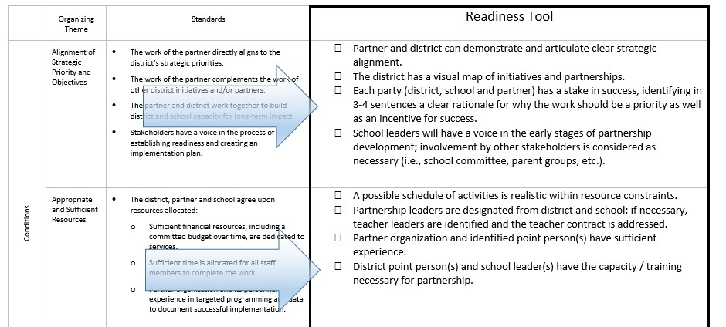

Purpose
Readiness for Partnership Tool – Purpose and Process
addressed. Finally, the two teams come together to work through

This is a tool that is recommended for use when a district and partner are considering whether to embark upon a partnership. After the initial conversations about partnership, each party would use the tool to identify areas of alignment and potential areas of concern in a future partnership.

Process
In order to consider whether each party is fully ready to engage, the two parties complete this readiness exercise separately. In a parallel process, the leadership teams from the district and the partner provide ratings about readiness based on their initial conversations. The process begins with each leadership team member providing a rating for the four categories (see the following rubric). The full leadership team then comes together to average the ratings and discuss areas of concern to be

Rating Scale
potential areas of concern that they have identified.

Notes on Use
The process of providing ratings is designed to help each group achieve consensus and identify areas of concern. There is NO THRESHOLD for a go/no-go decision; instead, this process identifies areas to explore and whether there is consensus overall to move forward. The ratings should provide a framework for decision making but should not make the decision for the group. Some of the items to address may be more important for specific partnerships, for example. When the district and partner come together to address issues that they have surfaced, it is not necessary to compare ratings. Each group should be able to provide areas in which they believe the partnership has some foundational strength as well as items to be addressed.

Rating | Descriptor
4 | There is likely agreement and alignment on all of the items to be addressed.
3 | There is likely agreement and alignment on most of the items to be addressed.
2 | There is more than one significant concern about the items to be addressed.
1 | There are several significant concerns about the items to be addressed.

Readiness for Partnership Tool

 | Items to Address |  | Rating (1-4) | Areas of Concern to be Addressed
Alignment of Strategic Priority and Objectives |  | Partner and district can demonstrate and articulate clear strategic alignment.
 |  | The district has a visual map of initiatives and partnerships.
Each party (district, school and partner) has a stake in success, identifying in 3-4 sentences a clear rationale for why the work should be a priority as well as an incentive for success.
School leaders will have a voice in the early stages of partnership development;
 |  | involvement by other stakeholders is considered as necessary (i.e., school
 |  | committee, parent groups).
Appropriate and Sufficient Resources |  | A possible schedule of activities is realistic within resource constraints.
Partnership leaders are designated from district and school;
if necessary, teacher leaders are identified and the teacher contract is addressed. Partner organization and identified point person(s) have sufficient experience. District point person(s) and school leader(s) have the capacity / training necessary
 |  | for partnership.
Clear Metrics Established |  | District, partner and school can agree upon clear outcome measures as well as
output measures.
District, partner and school agree upon how data will be collected and who will create reports on indicators of success on a regular basis (suggested at least
 |  | quarterly)
Ongoing |  | Point persons and higher authority with overall responsibility is identified for
 |  | district and partner.
 |  | A meeting schedule and ongoing agenda can be established.
 |  | Partner organization, district and school have a simple protocol for identifying and
 |  | resolving conflict and a mechanism for dissolving partnership if necessary.
Communication |  | The district and partner identify a structure for partner to partner communication
and Collaboration |  | as necessary.
 |  | Partner organization, district and school(s) can demonstrate
 |  | a solutions-oriented approach to working together.
 |  | Partner organization and district make reasonable efforts to keep staff and the
 |  | community informed of progress.

Framework for Contract Supplement Alignment
The second tool provides districts and partners with sample language to use in a contractual agreement that supports the conditions and habits of successful partnerships. This page provides a snapshot of how the tool was developed from the standards. (Appendix A provides the fully detailed alignment.) The next page provides a suggestion for use.

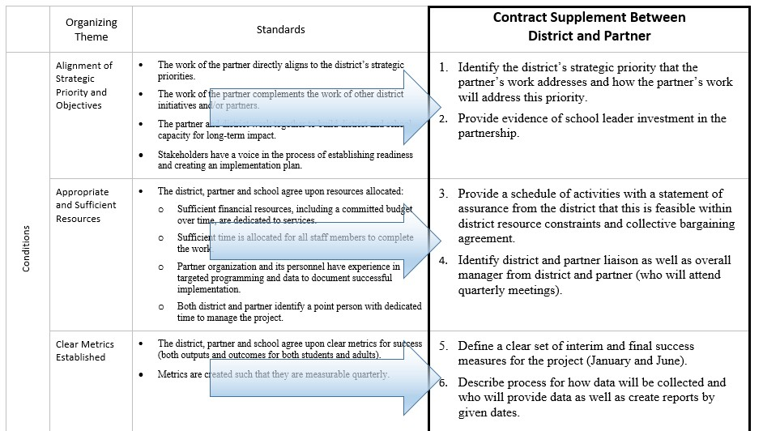

Purpose
Contract Supplement – Purpose and Process

The following language is designed to be added as an addendum, or accompanying memo of understanding, to any contract between a district and partner. The purpose is to be explicit about the necessary practices for ensuring an effective partnership.

Process
After the conversations about readiness have occurred and the partner and district are ready to engage in a formal agreement, this supplement can be added as an addendum or an accompanying memorandum.

Notes on Use
It is likely that partners and districts will want to include more specific items into this addendum.

Contract Supplement
Both [District Name] and [Partner Name] agree to adopt the Conditions and Habits of Successful Partnerships framework as non-binding guidance for the management of work conducted under this contract. As such, they agree to the following practices.
In advance of the commencement of work:
- Both parties have determined that the project aligns with the District’s strategic objectives.
- As applicable, the parties have discussed the project with District personnel that will be critical to the project’s success and have ensured that such personnel are prepared and supported to make the necessary investment of time and attention to the project.
- The Partner has provided the District with a written description of the schedule of activities required by District personnel, and the District has confirmed the schedule can be met within existing obligations, including collective bargaining agreements.
- The District and Partner have both identified project liaisons for the work and agree that the liaisons will serve as main points of contact for the project.
At the commencement of the work:
- The District and Partner have defined a set of interim and final outcomes for the project and have established a plan for collecting the outcome data.
- The District and Partner agree to meet monthly/quarterly to discuss project status and address any issues that may arise.

Quarterly Meeting Agenda Alignment
The final tool provides districts and partners with a sample hour-long agenda that aligns to the conditions and habits framework. This page provides a snapshot of how the tool was developed from the standards. (Appendix A provides the fully detailed alignment.) The next page provides a suggestion for use.

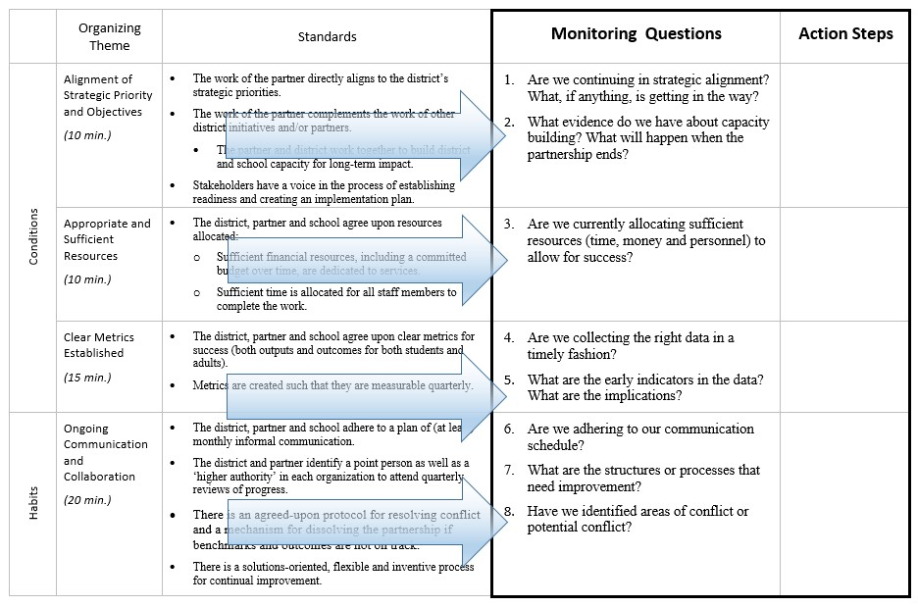

Purpose
Quarterly Meeting Agenda – Purpose and Process

This sample agenda is designed to be an in-person, 60-minute meeting between representatives of the district, partner and school. Attending this meeting are not only the on-site liaisons/point persons, but also individuals with greater responsibility from the district and partner. School leader participation is also encouraged for each of these meetings.

Process
A representative from both the district and the partner should spend approximately 60 minutes in preparation for this meeting. Preparation includes gathering data for the meeting that should include both agreed-upon metrics, as well as other stakeholder perception. Items from this meeting agenda can be used for ongoing meetings (weekly or monthly) between the district and the partner as well.

Notes on Use
It is important that representatives from each party (district, partner, school) are present at each and every meeting and that there are clear action items and a record of the conversation.

Sample Agenda for Quarterly Meeting
 | Monitoring Questions | Notes/Action Steps Needed
Alignment of Strategic Priority and Objectives  (10 min.) | Are we continuing in strategic allignment? What, if anything, is getting in the way?  What evidence do we have about capaity buiding? What will happen when the partnership ends?
Appropriate and Sufficient Resources  (10 min.) | Are we currently allocating sufficient resources (time, money and personnel) to allow for success?
Clear Metrics Established  (15 min.) | Are we collecting the right data in timely fashion?  What are the early indicators in the data? What are the implications of this data?
Ongoing Communication and Collaboration  (15 min.) | Are we adhering to our communication schedule?  What are the structures and processes that need improvement?  Have we identified areas of conflict or potential conflict?
Wrap-up  (5 min.) | Ensure ownership and timeline for action steps.

Appendix A – Alignment Tools

Readiness for Partnership Alignment

 | Organizing Theme |  | Standards | Readiness Tool
Conditions | Alignment of Strategic Priority and Objectives | •  •  •  • | The work of the partner directly aligns to the district’s strategic priorities.  The work of the partner complements the work of other district initiatives and/or partners.  The partner and district work together to build district and school capacity for long-term impact.  Stakeholders have a voice in the process of establishing readiness and creating an implementation plan. | - Partner and district can demonstrate and articulate clear strategic alignment.  - The district has a visual map of initiatives and partnerships.  - Each party (district, school and partner) has a stake in success, identifying in 3-4 sentences a clear rationale for why the work should be a priority as well as an incentive for success.  School leaders will have a voice in the early stages of partnership development; involvement by other stakeholders is considered as necessary (i.e., school committee, parent groups).
 | Appropriate and Sufficient Resources | • | The district, partner and school agree upon resources allocated:  - Sufficient financial resources, including a committed budget over time, are dedicated to services.  - Sufficient time is allocated for all staff members to complete the work.  - Partner organization and its personnel have experience in targeted programming and data to document successful implementation.  - Both district and partner identify a point person with dedicated time to manage the project. | - A possible schedule of activities is realistic within resource constraints.  - Partnership leaders are designated from district and school; if necessary, teacher leaders are identified and the teacher contract is addressed.  - Partner organization and identified point person(s) have sufficient experience.  District point person(s) and school leader(s) have the capacity / training necessary for partnership.
 | Clear Metrics | • | The district, partner and school agree upon clear | District, partner and school can agree upon clear outcome
 | Established | • | metrics for success (both outputs and outcomes  for both students and adults).  Metrics are created such that they are measurable quarterly. | measures as well as output measures.  District, partner and school agree upon how data will be collected and who will create reports on indicators of success on a regular basis (suggested at least quarterly)

Habits | Ongoing Communication and Collaboration | - The district, partner and school adhere to a plan of (at least) monthly informal communication.  - The district and partner identify a point person as well as a ‘higher authority’ in each organization to attend quarterly reviews of progress.  - There is an agreed-upon protocol for resolving conflict and a mechanism for dissolving the partnership if benchmarks and outcomes are not on track.  - There is a solutions-oriented, flexible and inventive process for continual improvement.  - There is an effort made to communicate formally on a quarterly basis about the status of the initiative. This effort includes communication with other partners. | - Point persons and higher authority with overall responsibility is identified for district and partner.  - A meeting schedule and ongoing agenda can be established.  - Partner organization, district and school have a simple protocol for identifying and resolving conflict and a mechanism for dissolving partnership if necessary.  - The district and partner identify a structure for partner to partner communication as necessary.  - Partner organization, district and school(s) can demonstrate a solutions-oriented approach to working together.  Partner organization and district make reasonable efforts to keep staff and the community informed of progress.

Contract Supplement Alignment
This contractual agreement (last column on right) is between the district and partner should be completed jointly, in a 90 minute meeting, and should include school leader participation.

 | Organizing Theme |  | Standards | Contract Supplement Between District and Partner
 | Alignment of Strategic Priority and Objectives | •  •  •  • | The work of the partner directly aligns to the district’s strategic priorities.  The work of the partner complements the work of other district initiatives and/or partners.  The partner and district work together to build district and school capacity for long-term impact.  Stakeholders have a voice in the process of establishing readiness and creating an implementation plan. | 1. Identify the district’s strategic priority that the partner’s work addresses and how the partner’s work will address this priority.  2. Provide evidence of school leader investment in the partnership.
 | Appropriate | • | The district, partner and school agree upon resources allocated: | 3. Provide a schedule of activities with a statement
 | and Sufficient |  | o Sufficient financial resources, including a committed budget | of assurance from the district that this is feasible
Conditions | Resources |  | over time, are dedicated to services.  - Sufficient time is allocated for all staff members to complete the work.  - Partner organization and its personnel have experience in targeted programming and data to document successful implementation.  o Both district and partner identify a point person with dedicated time to manage the project. | within district resource constraints and collective  bargaining agreement.  4. Identify district and partner liaison as well as overall manager from district and partner (who will attend quarterly meetings).
 | Clear Metrics | • | The district, partner and school agree upon clear metrics for success | 5. Define a clear set of interim and final success
 | Established | • | (both outputs and outcomes for both students and adults).  Metrics are created such that they are measurable quarterly. | measures for the project (January and June).  6. Describe process for how data will be collected and who will provide data as well as create reports by given dates.

Habits | Ongoing Communication and Collaboration | - The district, partner and school adhere to a plan of (at least) monthly informal communication.  - The district and partner identify a point person as well as a ‘higher authority’ in each organization to attend quarterly reviews of progress.  - There is an agreed-upon protocol for resolving conflict and a mechanism for dissolving the partnership if benchmarks and outcomes are not on track.  - There is a solutions-oriented, flexible and inventive process for continual improvement.  - There is an effort made to communicate formally on a quarterly basis about the status of the initiative. This effort includes communication with other partners. | 7. Provide a meeting schedule and draft agenda for monthly communication. Include in the draft agenda:  o a means for identifying and resolving conflict  o a means for ongoing improvement is evident

horizontal line

Quarterly Meeting Agenda Alignment

 | Organizing Theme |  | Standards | Monitoring Questions | Action Steps
 | Alignment of Strategic Priority and Objectives  (10 min.) | •  •  •  • | The work of the partner directly aligns to the district’s strategic priorities.  The work of the partner complements the work of other district initiatives and/or partners.  The partner and district work together to build district and school capacity for long-term impact.  Stakeholders have a voice in the process of establishing readiness and creating an implementation plan. | 1. Are we continuing in strategic alignment? What, if anything, is getting in the way?  2. What evidence do we have about capacity building? What will happen when the partnership ends?
 | Appropriate | • | The district, partner and school agree upon resources | 3. Are we currently allocating
Conditions | and Sufficient Resources  (10 min.) |  | allocated:  - Sufficient financial resources, including a committed budget over time, are dedicated to services.  - Sufficient time is allocated for all staff members to complete the work.  - Partner organization and its personnel have experience in targeted programming and data to document successful implementation.  o Both district and partner identify a point person with dedicated time to manage the project. | sufficient resources (time,  money and personnel) to allow for success?
 | Clear Metrics | • | The district, partner and school agree upon clear metrics | 4. Are we collecting the right
 | Established |  | for success (both outputs and outcomes for both students | data in a timely fashion?
 | (15 min.) | • | and adults).  Metrics are created such that they are measurable quarterly. | 5. What are the early indicators in the data? What are the implications?

Habits | Ongoing Communication and Collaboration  (20 min.) | - The district, partner and school adhere to a plan of (at least) monthly informal communication.  - The district and partner identify a point person as well as a ‘higher authority’ in each organization to attend quarterly reviews of progress.  - There is an agreed-upon protocol for resolving conflict and a mechanism for dissolving the partnership if benchmarks and outcomes are not on track.  - There is a solutions-oriented, flexible and inventive process for continual improvement.  - There is an effort made to communicate formally on a quarterly basis about the status of the initiative. This effort includes communication with other partners. | - Are we adhering to our communication schedule?  - What are the structures or processes that need improvement?  8. Have we identified areas of conflict or potential conflict?

Appendix B – Three tools to print

Readiness for Partnership Tool

 | Items to Address | Rating (1-4) | Areas of Concern to be Addressed
Alignment of Strategic Priority and Objectives | - Partner and district can demonstrate and articulate clear strategic alignment.  - The district has a visual map of initiatives and partnerships.  - Each party (district, school and partner) has a stake in success, identifying in 3-4 sentences a clear rationale for why the work should be a priority as well as an incentive for success.  - School leaders will have a voice in the early stages of partnership development; involvement by other stakeholders is considered as necessary (i.e., school committee, parent groups).
Appropriate and Sufficient Resources | - A possible schedule of activities is realistic within resource constraints.  - Partnership leaders are designated from district and school; if necessary, teacher leaders are identified and the teacher contract is addressed.  - Partner organization and identified point person(s) have sufficient experience.  - District point person(s) and school leader(s) have the capacity / training necessary for partnership.
Clear Metrics Established | - District, partner and school can agree upon clear outcome measures as well as output measures.  - District, partner and school agree upon how data will be collected and who will create reports on indicators of success on a regular basis (suggested at least quarterly)

 | Items to Address | Rating (1-4) | Areas of Concern to be Addressed
Ongoing Communication and Collaboration | - Point persons and higher authority with overall responsibility is identified for district and partner.  - A meeting schedule and ongoing agenda can be established.  - Partner organization, district and school have a simple protocol for identifying and resolving conflict and a mechanism for dissolving partnership if necessary.  - The district and partner identify a structure for partner to partner communication as necessary.  - Partner organization, district and school(s) can demonstrate a solutions-oriented approach to working together.  - Partner organization and district make reasonable efforts to keep staff and the community informed of progress.

Contract Supplement

Both [District Name] and [Partner Name] agree to adopt the Conditions and Habits of Successful Partnerships framework as non-binding guidance for the management of work conducted under this contract. As such, they agree to the following practices.
In advance of the commencement of work:
- Both parties have determined that the project aligns with the District’s strategic objectives.
- As applicable, the parties have discussed the project with District personnel that will be critical to the project’s success and have ensured that such personnel are prepared and supported to make the necessary investment of time and attention to the project.
- The Partner has provided the District with a written description of the schedule of activities required by District personnel, and the District has confirmed the schedule can be met within existing obligations, including collective bargaining agreements.
- The District and Partner have both identified project liaisons for the work and agree that the liaisons will serve as main points of contact for the project.
At the commencement of the work:
- The District and Partner have defined a set of interim and final outcomes for the project and have established a plan for collecting the outcome data.
- The District and Partner agree to meet monthly/quarterly to discuss project status and address any issues that may arise.

 | Monitoring Questions | Notes/Action Steps Needed
Alignment of Strategic Priority and Objectives  (10 min.) | Are we continuing in strategic allignment? What, if anything, is getting in the way?  What evidence do we have about capaity buiding? What will happen when the partnership ends?
Appropriate and Sufficient Resources  (10 min.) | Are we currently allocating sufficient resources (time, money and personnel) to allow for success?
Clear Metrics Established  (15 min.) | Are we collecting the right data in timely fashion?  What are the early indicators in the data? What are the implications of this data?
Ongoing Communication and Collaboration  (15 min.) | Are we adhering to our communication schedule?  What are the structures and processes that need improvement?  Have we identified areas of conflict or potential conflict?
Wrap-up  (5 min.) | Ensure ownership and timeline for action steps.
Quarterly Meeting Agenda

